Sheshadri rao gudlavalleru engineering college



INTRODUCTION

Financial risk management is the processing of handling and managing anticipated and current financial threats at an enterprise or firm by a good strategic plan that could possibly stop the revenue leakage.

However, financial risk management plan does not protect a firm from all the financial losses and possible risks. While some risks are expected, the others are behind the stage, unexpected or do not get addressed quickly.

Financial institutions need to continually weigh the risks of their transactions, and they determine their risk level through credit scoring. Leading up to the 2008-09 financial crisis, almost all large banks used credit scoring models based on statistical theories; that crisis, largely brought about by underestimating risk, proved the need for better accuracy in their scoring. The combination of increased requirements and the development of advanced new technologies has given rise to a new era: credit scoring using machine learning.

TECHNICAL ARCHITECHTURE:

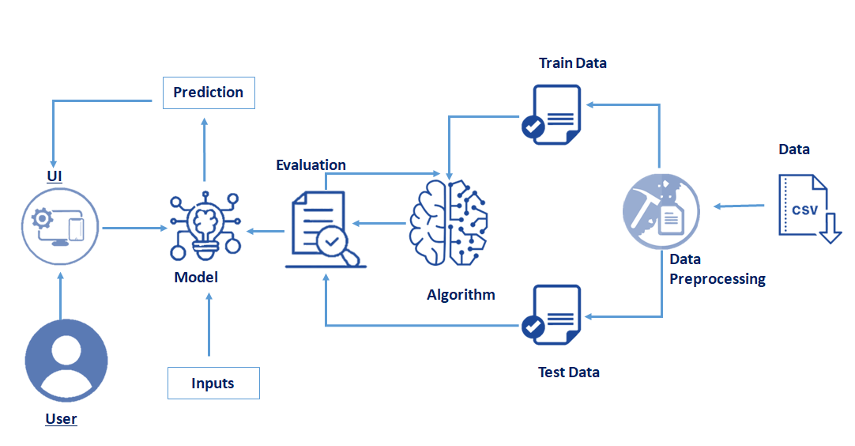

LITERATURE SURVEY

EXSISTING PROBLEM:

Here are some financial risk management problems that might fail your strategy and drag you at the verge of facing potential financial risks:

1. Economic factors.
2. Your supplier’s or external parties’ decisions and actions.
3. Financial instability in the market.
4. Legal interventions.
5. Internal call-to-actions.

Proposed solution:

1. Define all the high organizational level structures and product frames to support financial reporting.
2. Simulate all the possible default cashflows and accruals for the financial risk management software.
3. Quantify and manage the interest rate risk.

THEORETICAL ANALYSIS

Block diagram:

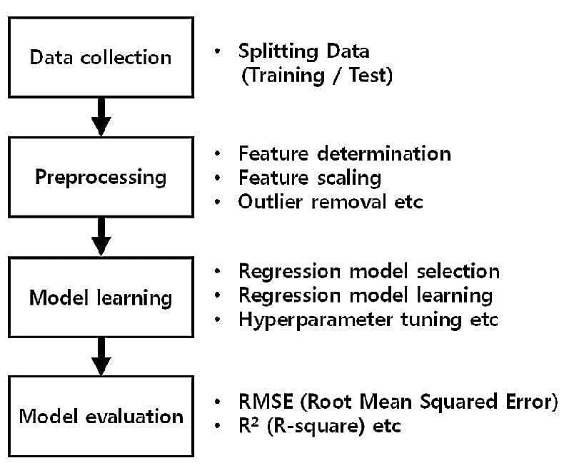

HARDWARE/ SOFTWARE REQUIREMENTS

Recommended System Requirements

● Processors:Intel® Core™ i5 processor 4300M at 2.60 GHz or 2.59 GHz (1 socket, 2 cores, 2 threads per core), 8 GB of DRAMIntel® Xeon® processor E5-2698 v3 at 2.30 GHz (2 sockets, 16 cores each, 1 thread per core), 64 GB of DRAMIntel® Xeon Phi™ processor 7210 at 1.30 GHz (1 socket, 64 cores, 4 threads per core), 32 GB of DRAM, 16 GB of MCDRAM (flat mode enabled)

● Disk space: 2 to 3 GB

● Operating systems: Windows® 10, macOS*, and Linux* Minimum System Requirements

● Processors: Intel Atom® processor or Intel® Core™ i3 processor

● Disk space: 1 GB

● Operating systems: Windows* 7 or later, macOS, and Linux

● Python* versions: 3.9

**softwares we used:**

**Anaconda navigator:**

Anaconda is an open-source distribution for python and R. It is used for data science, machine learning, deep learning, etc. With the availability of more than 300 libraries for data science, it becomes fairly optimal for any programmer to work on anaconda for data science.

**Pycharm:**

PyCharm is a dedicated Python Integrated Development Environment (IDE) providing a wide range of essential tools for Python developers, tightly integrated to create a convenient environment for productive Python, web, and data science development

FLOW CHART

|  |
| --- |
| Data Collection |

↓

|  |
| --- |
| Import the Libraries and Importing the dataset. |

↓

|  |
| --- |
| Checking for Null values and Data visualization |

↓

|  |
| --- |
| Tacking care of Missing Data |

↓

|  |
| --- |
| Label Encoding and OneHot Encoding |

↓

|  |
| --- |
| Splitting Data into Train and Test |

↓

|  |
| --- |
| Training and Testing the Model |

↓

|  |
| --- |
| Evalution of Model and Save the Model |

↓

|  |
| --- |
| Create an HTML file and PYTHON code |

↓

|  |
| --- |
| Train the Machine Learning Model On IBM |

↓

|  |
| --- |
| Integrate Flask with Scoring End Point |

Result?

1. For checking the prediction we need to give the input values.
2. Then click on submit it show the prediction value

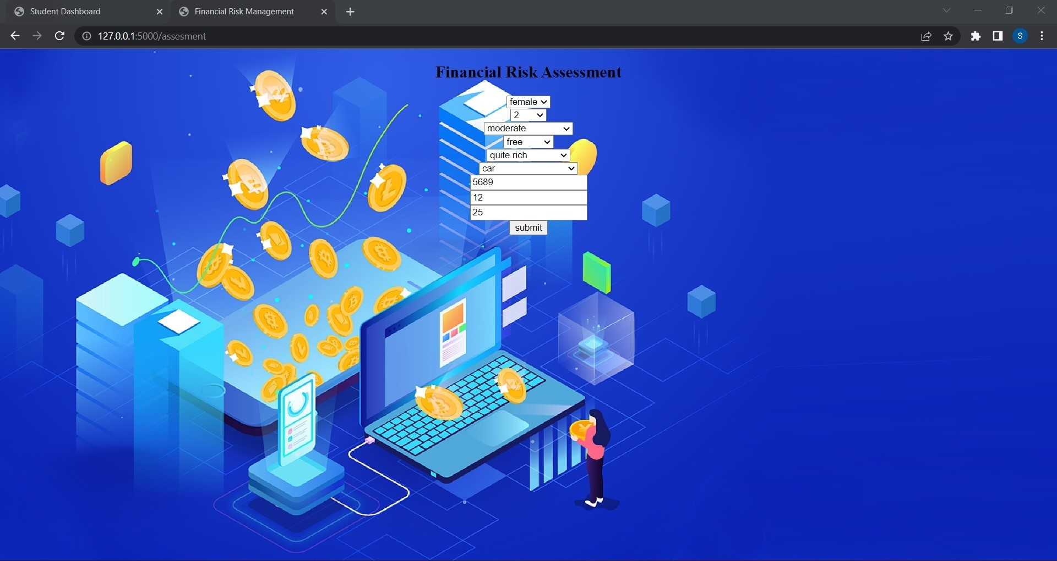

1. If the prediction is risk it show and says BAD
2. If the prediction is not at risk it show and says GOOD

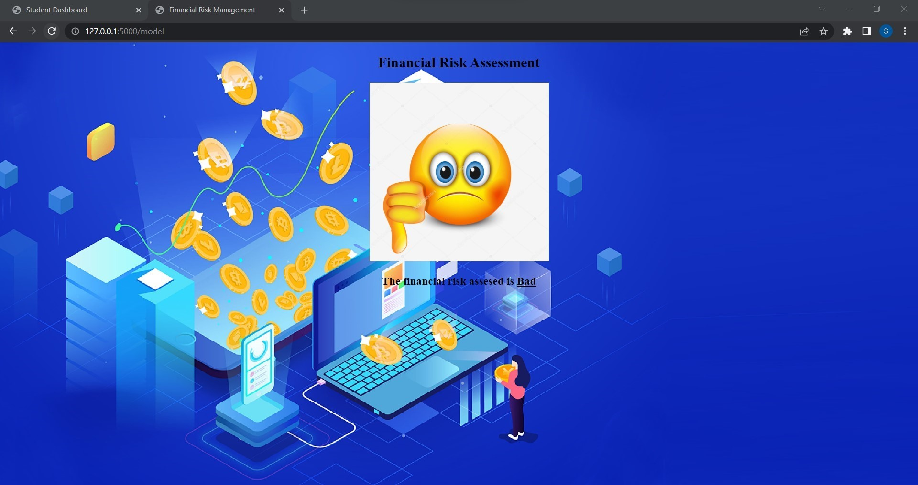

ADVANTAGES & DISADVANTAGES

Advantages:

1. See risks that are not apparent
2. Providing insights and support to the Board of Directors
3. Get credit for cooperation
4. Build a better defense to class-actions
5. Reduce business liability
6. Frame regulatory issues

Disadvantages:

1. Not Suitable For All Organisation
2. Expensive
3. Training Costs
4. Loss of Focus Due to Automation
5. Data Security Issue
6. Authorship/Referencing – About the Author(s)

APPLICATIONS

Application risk management is the process of identifying potential threats and implementing improvement efforts to alleviate or prevent possible negative events resulting to your business - or job.

1. Improved System Performance and Reliability
2. Reduced Technical Debt
3. Compliance to Architecture and Coding Standards
4. Increased Vendor Value
5. Reduce System Outages and Other Business Risks

CONCLUSION

Risk management is an important process that managers should maintain in an organization. It is inevitable to have risks and managers should have better strategies to deal with risks. The long-term survival of an organization depends on the ability to manage risks. The intensifying competition in the global markets has forced managers to focus on maintaining a strong risks management program by establishing values.

Complying with the values and cultural aspects of an organization is important in achieving the goals and objectives of an organization. The culture of an organization determines its success in the market environment. It is a reflection of the beliefs and attitudes that people have towards the organizational systems.

Culture is developed and shaped by the stakeholders of the organization. Change management is very important to an organization and managers should possess the required skills of carrying out this process. Therefore, risks management is an important activity for organization in the modern market environment and all managers should embrace it for the long-term survival of their businesses.

Scope of financial risk management

FRM or Financial Risk Management is an advanced certification in the field of finance. A FRM professional is essentially responsible for foreseeing, analysing and controlling various credit and market risks that the firm may be exposed to in the process of creating value. Not only that, a Financial Risk Manager is responsible to assess and take suitable measures to control Inflation risk, Sector risk, Foreign exchange risk, Volatility risk, Shape risk, Liquidity risk etc. Why FRM certification is needed? While any finance professional, having extensive knowledge about the fields of economy and finance can work as a Financial Risk Manager, most reputed risk management firms give immense value to a FRM credential. Thus, FRM certification is a must for any aspiring Financial Risk Manager. The credential gives one in-depth understanding of world economy, financial markets and products, various risk models etc. Although the certification gives rigorous knowledge about risk management, one has to be capable of taking calculated risks while working under tremendous pressure in order to succeed as a FRM professional. Career opportunities in India after FRM is a highly sought after credential throughout the world. While large-scale risk management firms remain as major employers of FRM professionals, one can work as a freelance Financial Risk Manager too. Although most major corporations and investment bankers take FRM services from risk management firms, few employs FRM professionals under their pay roll too. After receiving the FRM certification one can aim for positions such as Risk Quantification Manager, Credit risk specialist, Market risk specialist, Enterprise Risk Manager, Operational risk analysts, Regulatory risk analysts etc. The remuneration and other perks for FRM professionals are generally quite high. Most of the job profiles require extensive travelling and high pressure working environment too. However, if finance is your passion and calculative risk taking your speciality, then career as a FRM professional can be highly rewarding for you.

BIBLOGRAFHY

**Installation of Anaconda Navigator:**

<https://www.youtube.com/embed/5mDYijMfSzs>

**Installation Of Py charm Professionals:**

**<https://www.youtube.com/embed/z73PyNDgVyQ>**

**Installation Of Python packages:**

**<https://www.youtube.com/embed/akj3_wTploU>**

**Data collection:**

**<https://www.kaggle.com/crawford/80-cereals>**

**Data Preprocessing :**

**<https://thesmartbridge.com/documents/spsaimldocs/Datapreprocessing.pdf>**

**Handling null values:**

**<https://towardsdatascience.com/7-ways-to-handle-missing-values-in-machine-learning-1a6326adf79e>**

**Data Visualization:**

**<https://www.youtube.com/embed/TLdXM0A7SR8>**

**Splitting Dependent And Independent Columns:**

**<https://www.youtube.com/embed/A_V6daPQZIU>**

**Splitting The Data Into Train And Test:**

**<https://www.youtube.com/embed/xgDs0scjuuQ>**

**Training and testing the model:**

**<https://www.youtube.com/embed/yIYKR4sgzI8>**

**Model Evaluation:**

**<https://towardsdatascience.com/the-5-classification-evaluation-metrics?you-must-know-aa97784ff226>**

**Flask Frame Work Reference: <https://www.youtube.com/embed/lj4I_CvBnt0>**

**Flask Refarance To Run:**

**<https://www.youtube.com/embed/UbCWoMf80PY>**

**Train The Model On IBM:**

**Account Creation:**

**<https://www.youtube.com/embed/4y_zD-0Q3F8>**

**Train Model On IBM Watson:**

**<https://www.youtube.com/embed/TysuP3KgSzc>**

**Integrate Flask With Scoring Endpoint:**

**<https://www.youtube.com/embed/ST1ZYLmYw2U>**